**1. Book a Branding Breakthrough Session(Replace content)**

**2. Replace image with mp4**

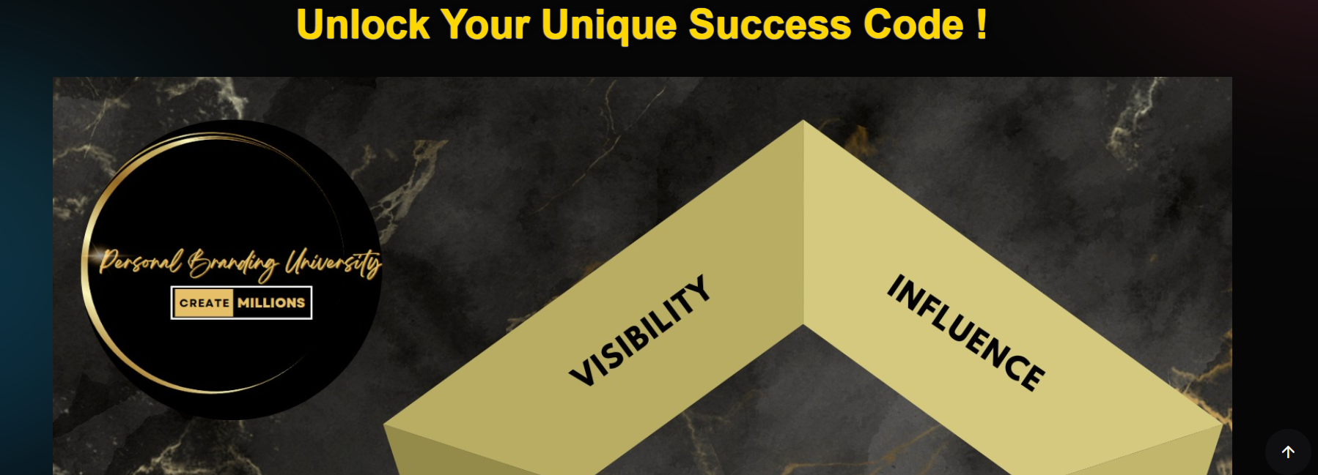

**3. With mansi pic write quete (You are your best investment- Dr. Mansi Shah).**

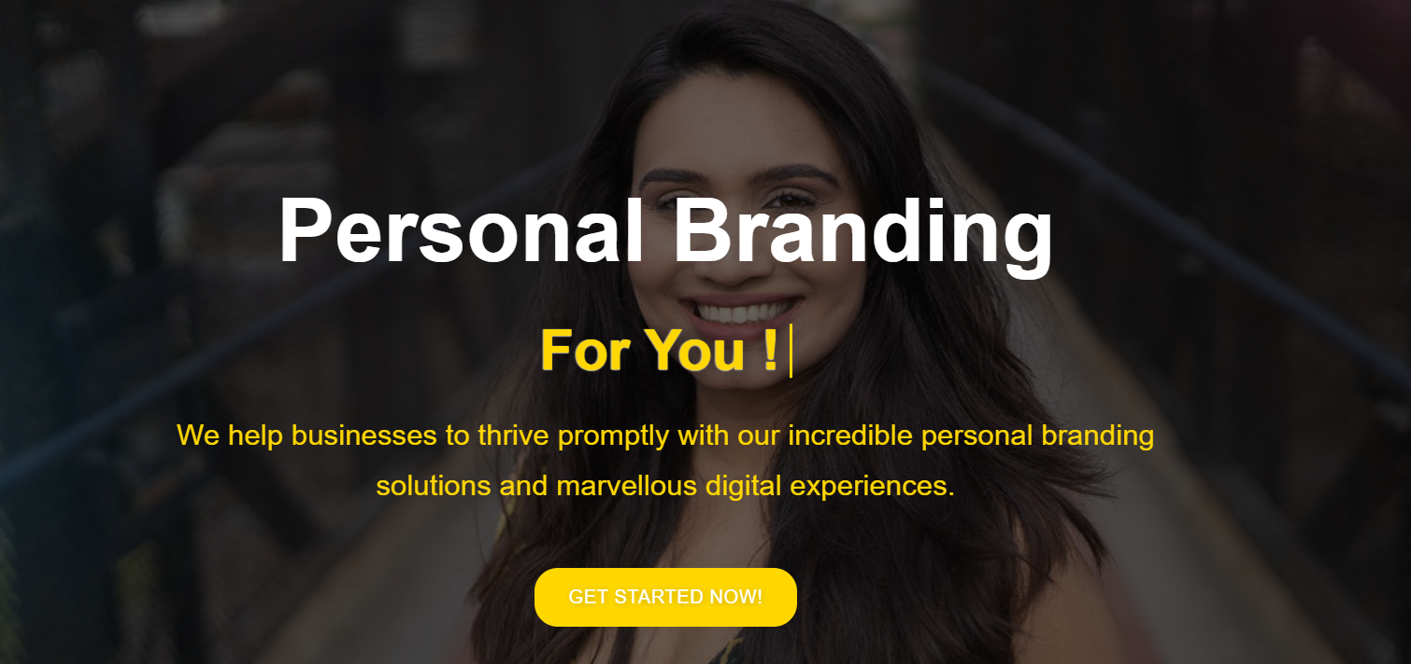

**4. This will be same**

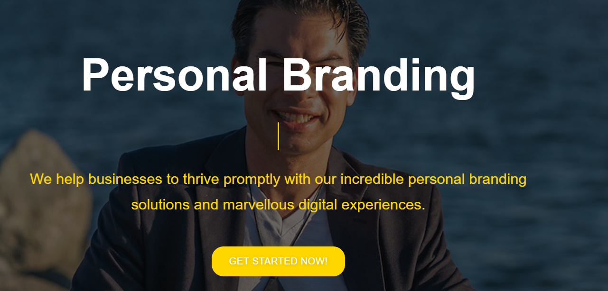

**5. Remove this section or replace with point 6.**

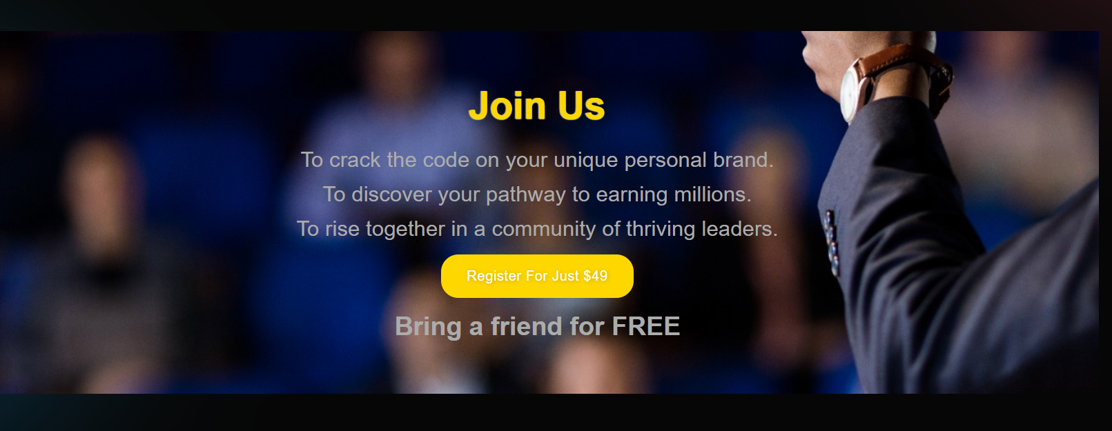

**6. Create a section with name (Branding Breakthrough Session at University Club) Image is shared on whatsapp**